PortSwigger Web Security Academy — Proof of Concept

Prototype Pollution Lab 5

Client-side prototype pollution via browser APIs
Category | Prototype Pollution
Lab | Lab 5
Completed By | Security Researcher
Platform | PortSwigger Web Security Academy

Lab Objective
Exploit prototype pollution via browser APIs (fetch/XMLHttpRequest) to trigger DOM XSS.

Step-by-Step Exploitation
- Open Burp Suite and configure browser proxy.
- Navigate to the lab URL and identify the vulnerable functionality.
- Intercept the relevant HTTP request in Burp Proxy.
- Send the request to Burp Repeater for analysis.
- Craft and inject the appropriate payload into the vulnerable parameter.
- Forward the modified request and observe the response.
- Verify the exploit was successful as shown in the screenshots below.

Screenshots & Evidence
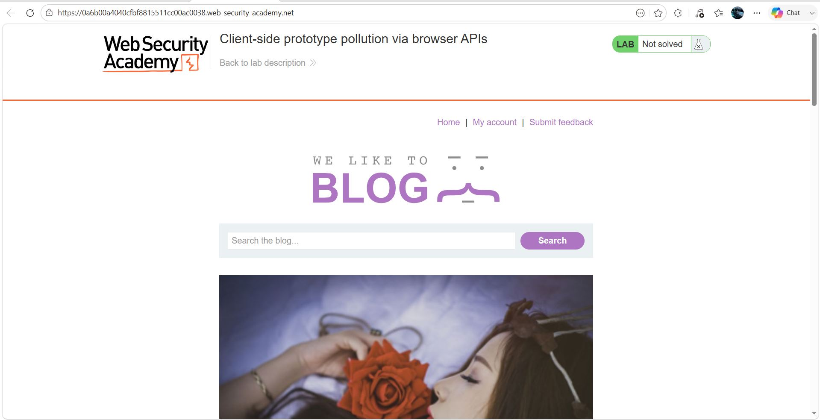
Figure 1: Lab 5 1
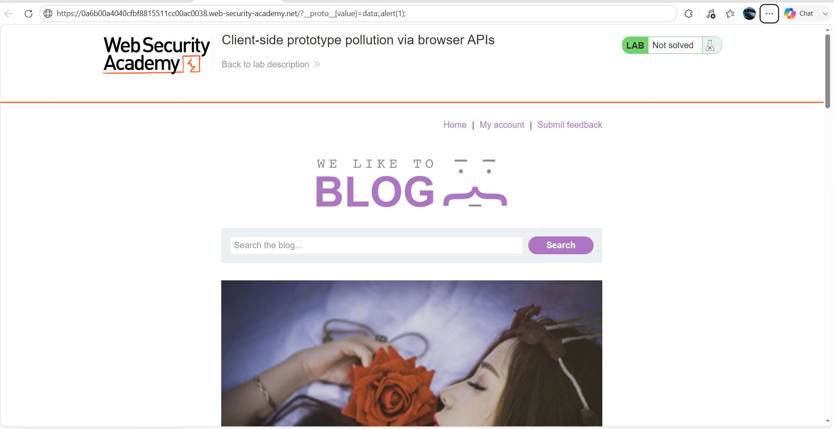
Figure 2: Lab 5 2
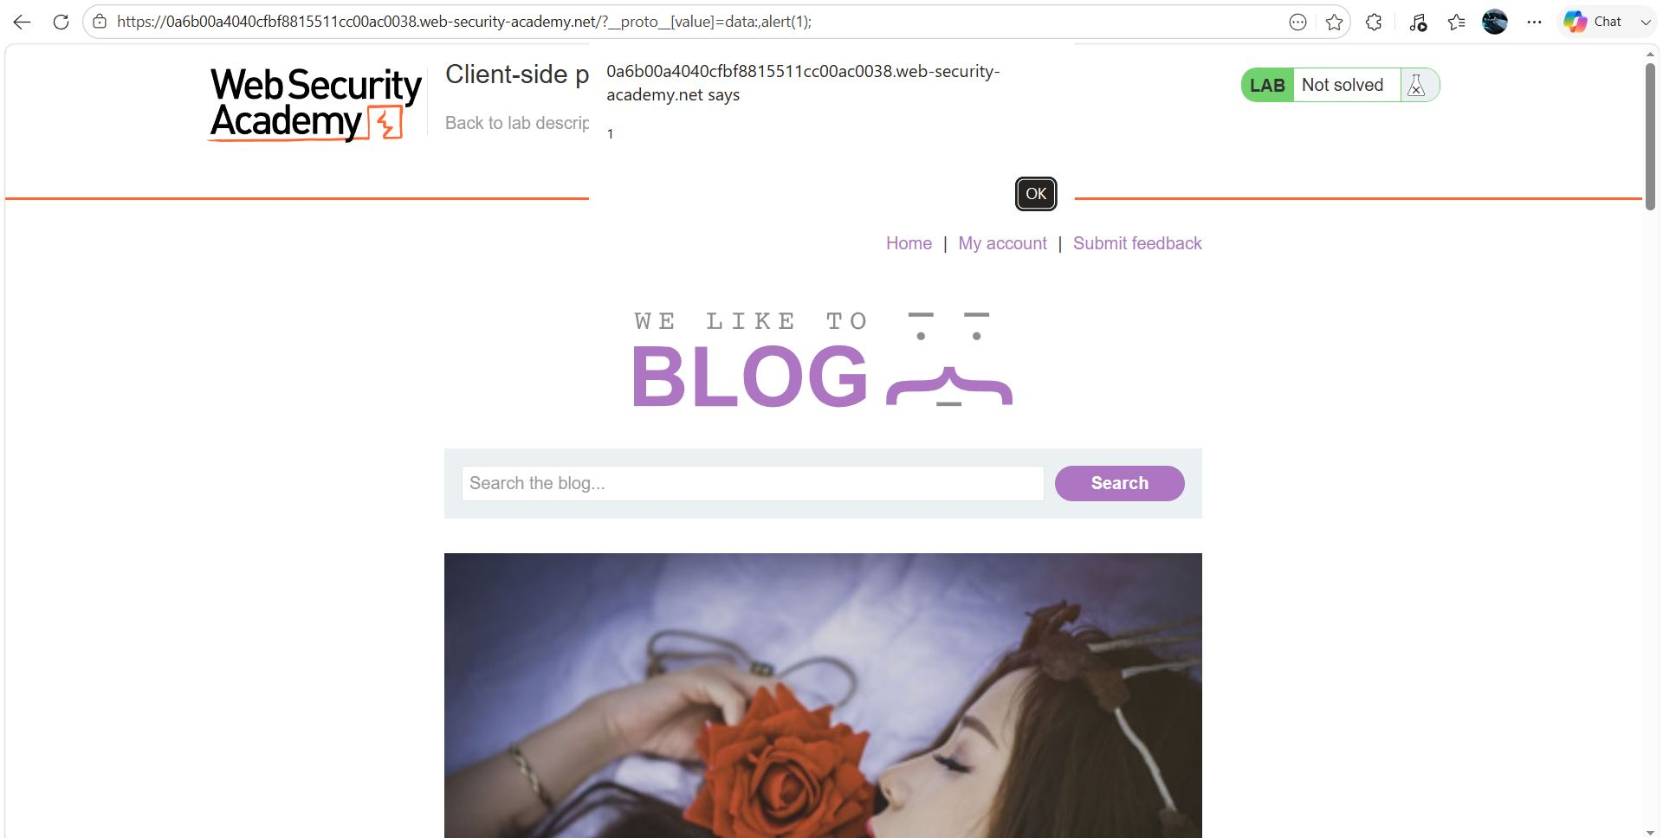
Figure 3: Lab 5 3
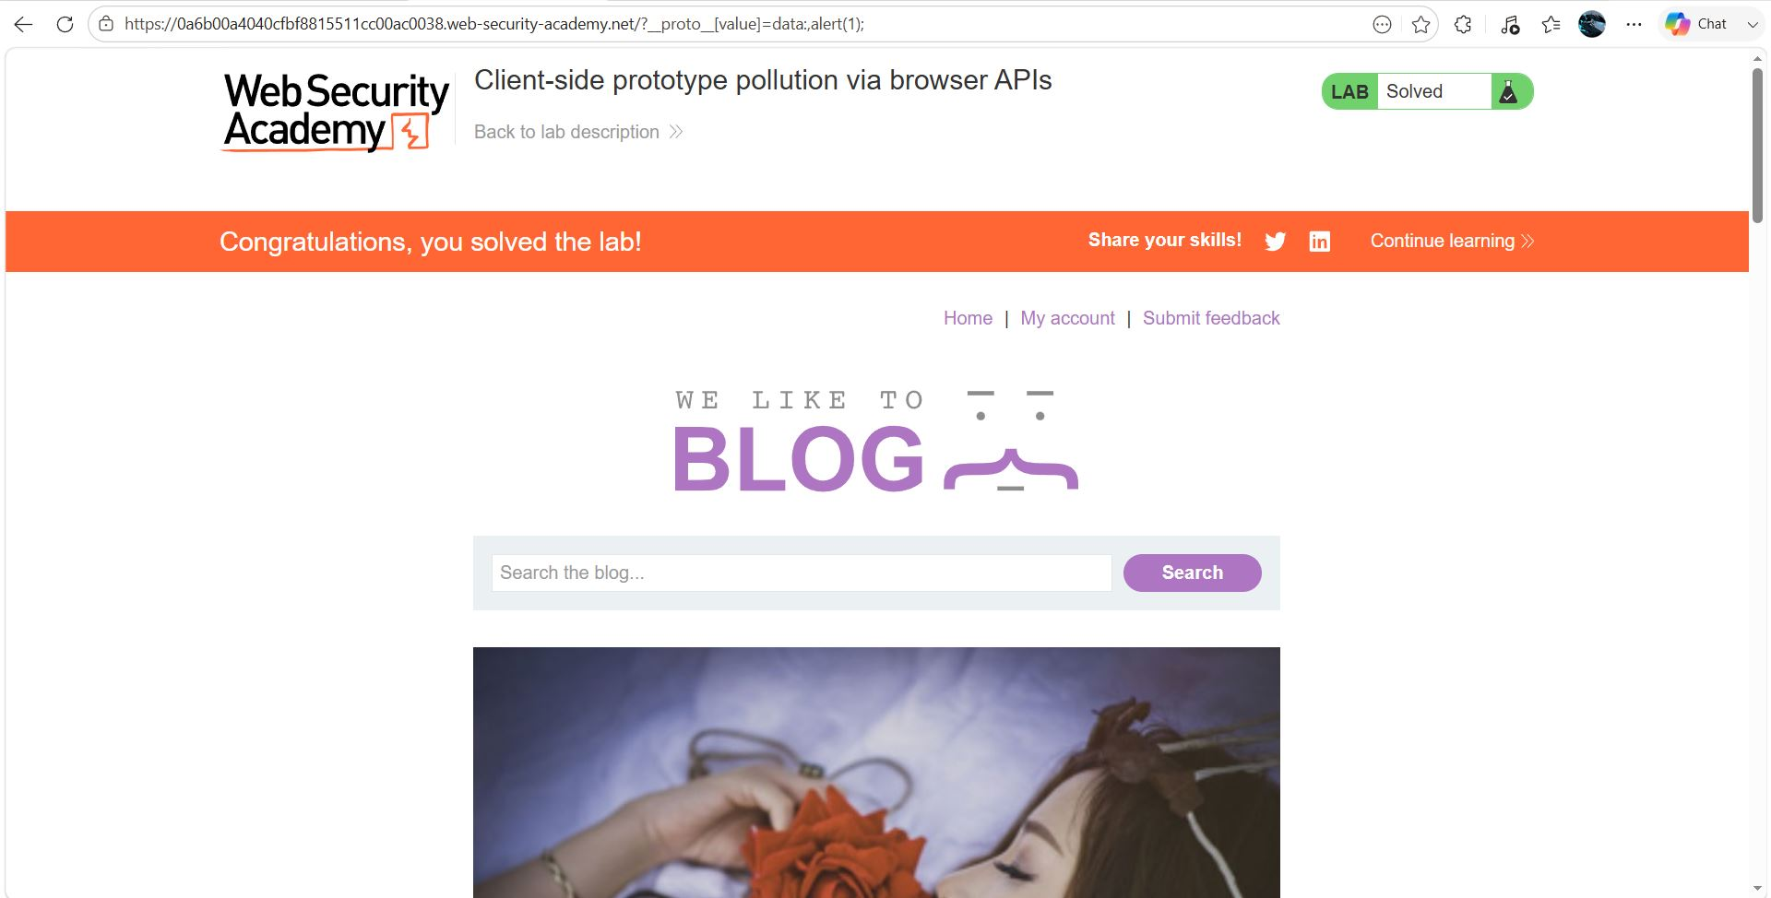
Figure 4: Lab 5 4

Lab Status: SOLVED

